**Computer Networks Laboratory**

**Assignment 7**

Name: Anirban Das Class: BCSE-III  Roll: 001910501077  Group: A3

**Problem Statement:**

Network, Transport and Application layer protocols.

Implement any two protocols using TCP/UDP Socket as suitable:

1. BOOTP

2. FTP

3. DHCP

4. BGP

5. RIP

**Design:**

TCP/UDP Sockets:

To manage the connection between application layer network protocols, TCP and UDP use ports and sockets. TCP and UDP operate at the host-to-host layer in the IP communication model and provide host-to-host communication services for the application layer protocol. This means an application layer protocol is on one IP host connecting to an application layer protocol on another IP host.

TCP is a connection-oriented protocol. Connection-orientation means that the communicating devices should establish a connection before transmitting data and should close the connection after transmitting the data.

UDP is the Datagram oriented protocol. This is because there is no overhead for opening a connection, maintaining a connection, and terminating a connection. UDP is efficient for broadcast and multicast type of network transmission.

PROTOCOLS IMPLEMENTED

File Transfer Protocol:

The **File Transfer Protocol** (**FTP**) is a standard communication protocol used for the transfer of computer files from a server to a client on a computer network. FTP is built on a client–server model architecture using separate control and data connections between the client and the server.

TCP Sockets are used to implement the client-server model in File Transfer Protocol. The following flow diagram explains the control flow of the algorithm:

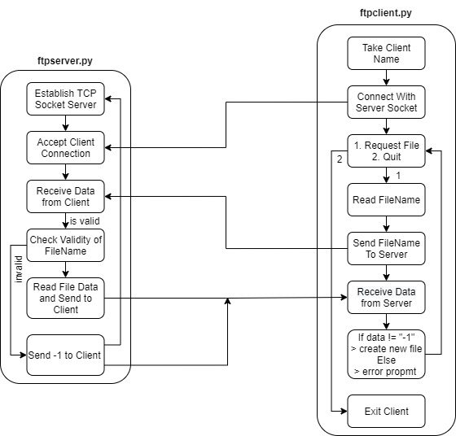

Dynamic Host Control Protocol:

The **Dynamic Host Configuration Protocol** (**DHCP**) is a network management protocol used on Internet Protocol (IP) networks for automatically assigning IP addresses and other communication parameters to devices connected to the network using a client–server architecture.

UDP Sockets are used to implement the client-server model in File Transfer Protocol. The following flow diagram explains the control flow of the algorithm:

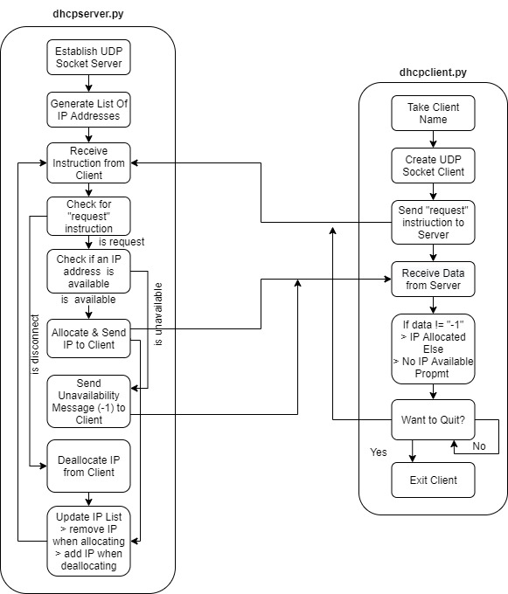

**Implementation:**

Dynamic Host Control Protocol

**server**

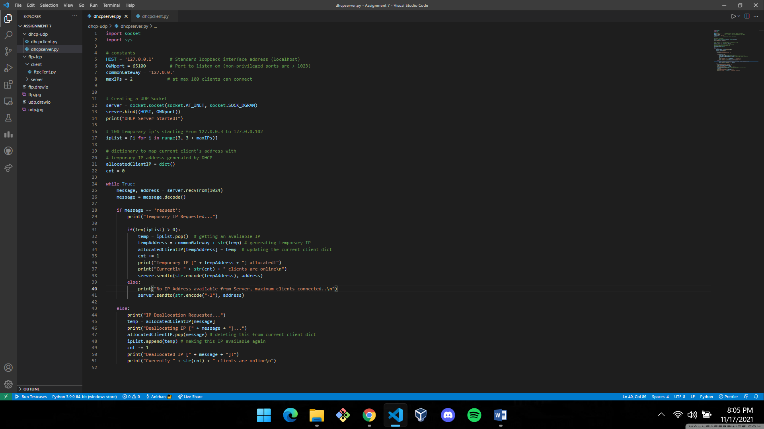

**client**

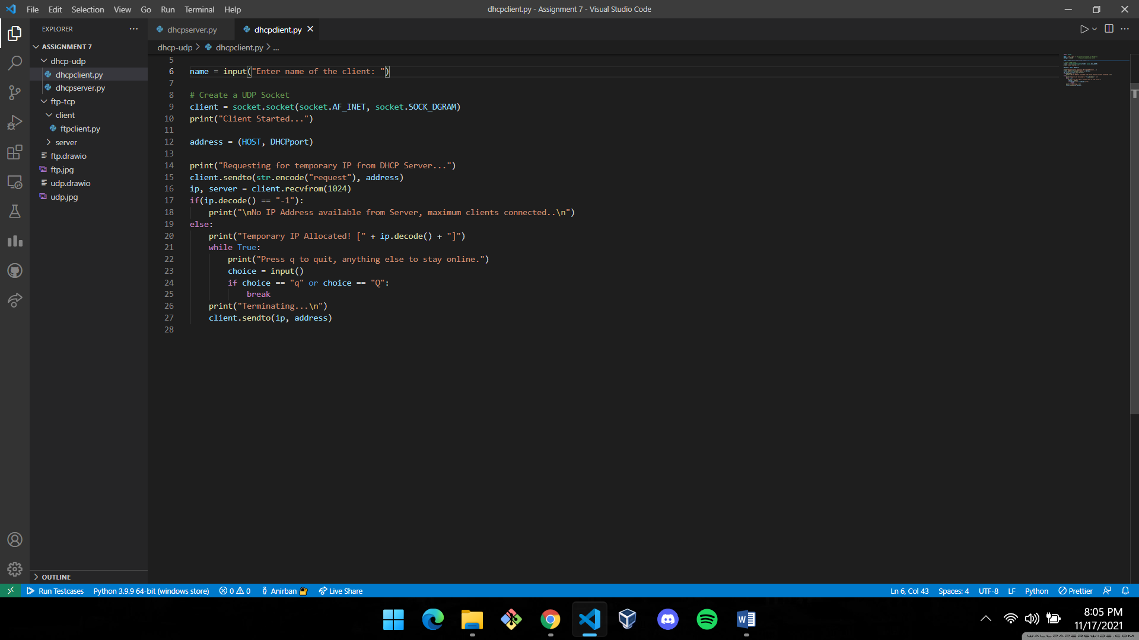

File Transfer Protocol

**server**

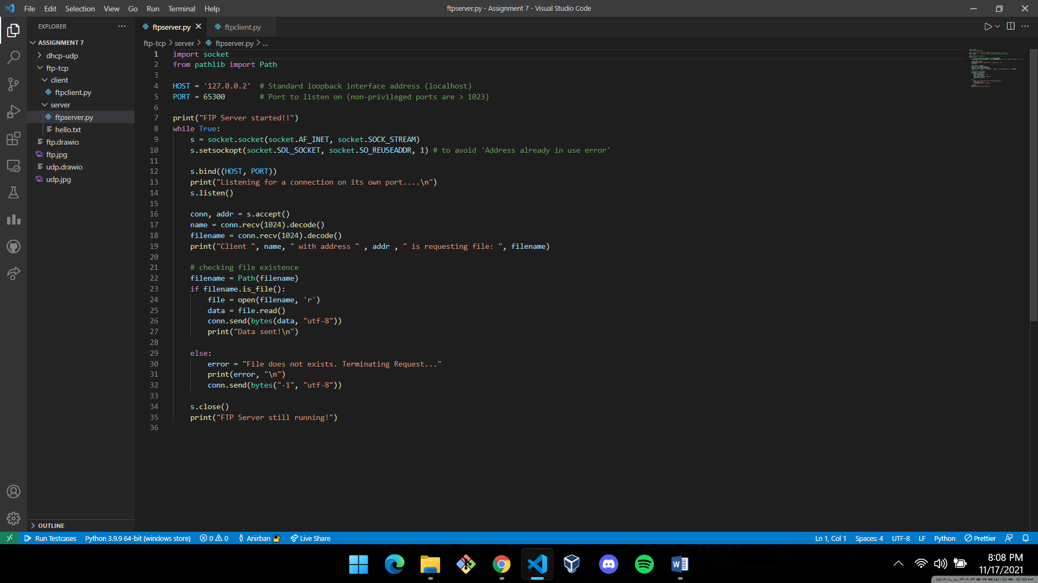

**client**

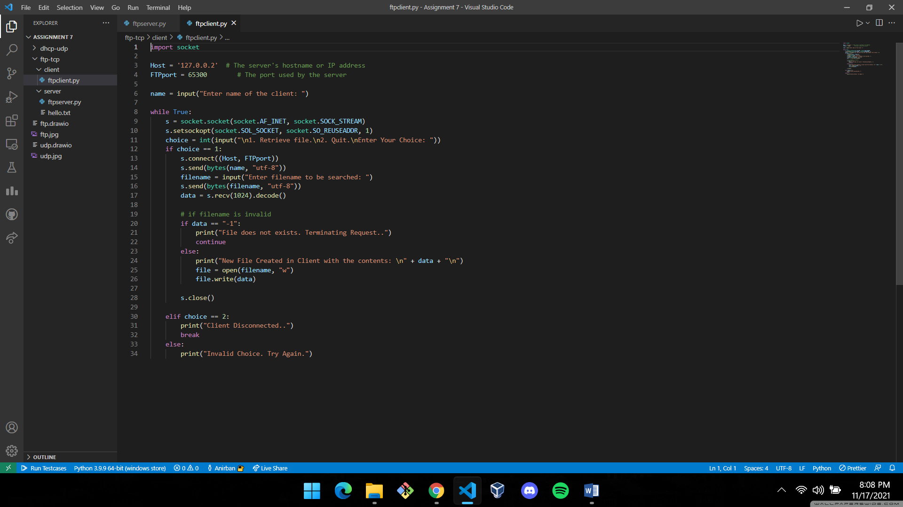

**Results & Output:**

File Transfer Protocol

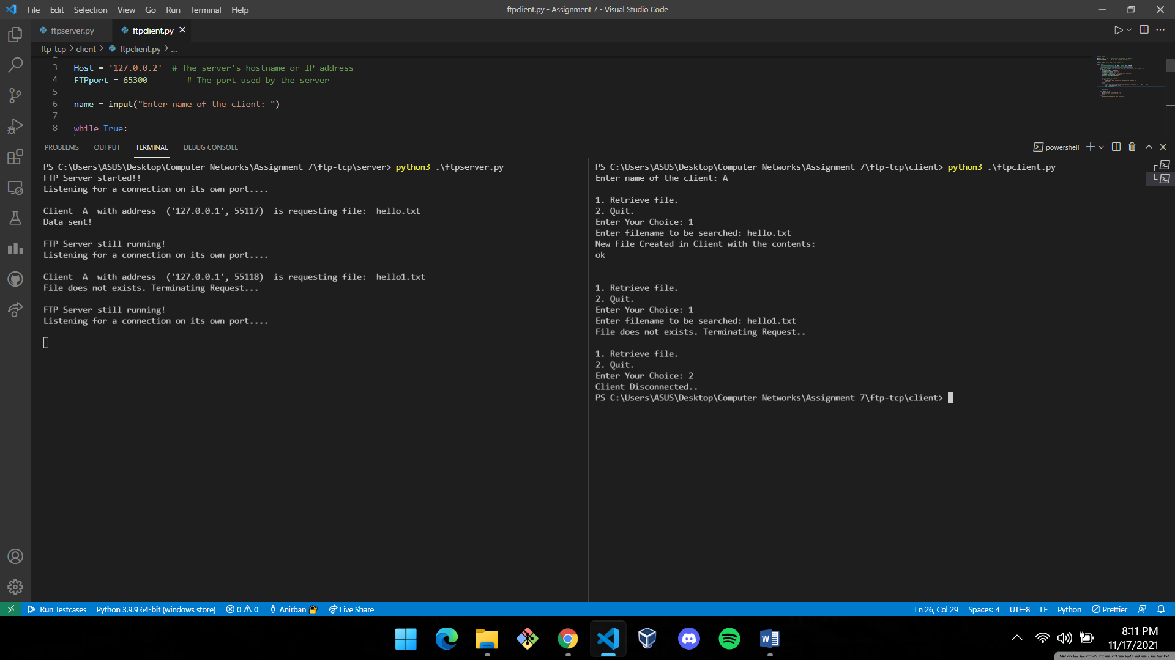

Dynamic Host Control Protocol

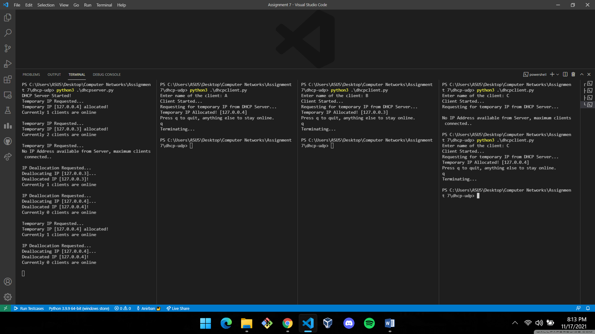

**Comments:**

This assignment helped me understand the working procedure of FTP and DHCP protocols and successfully implementing them using TCP/UDP sockets in Python 3.